Python Programming, Basics and Data Structures (https://www.kaggle.com/discussions/general/511386)

Tuples are immutable and this better than lists for read-only sequences; tuple ( )
Sets are fastest for membership tests; set {}
Dictionaries are best for key-value pair storage; dict {}
Lists are most flexible for dynamic, ordered sequences; list [ ]

While in all others one uses .remove to remove elements from the collection, with dict:

Removing key-value pairs
del person["city"]
print(person) # Output: {'name': 'Alice', 'age': 31, 'email': 'alice@example.com'}

While in all others, iteration is done as: for fruits in fruit_set
print(fruit)

in dict; for key, value in person.items():
print(f"{key}: {value}")

Object Oriented Programming

OOP is a way of writing code that focuses on organising data (attributes), and actions(methods/functions) together into objects. These objects are instances of classes acting as blueprints that define how the objects can be structured and what they can do.

Here we have defined the dog with 2 methods: init, bark; and 2 attributes: name, age. The init method is a special constructor method that is automatically called when a new object is created. It initialises the object’s attributes with the provided values.

We then created an instance of the dog class called dog 1, passing the name, Buddy, and age 3 as arguments. We then used the bark method to make dog1 bark and the display_age method to show its age.

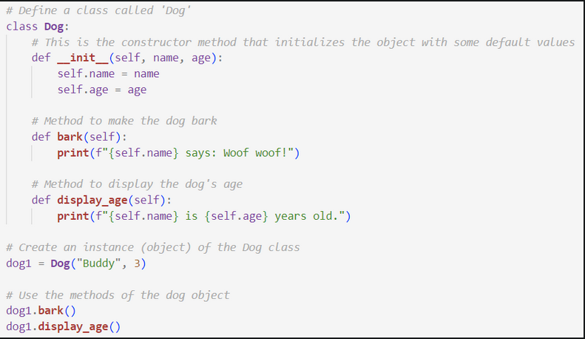
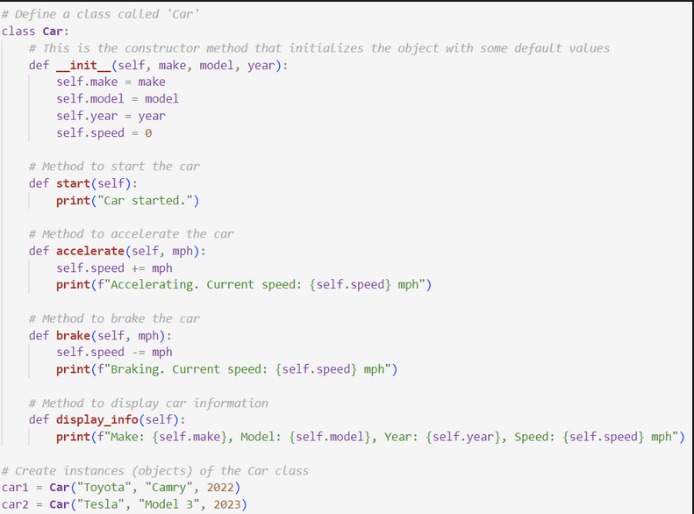
Here we define a class car with 4 methods (init, start, accelerate, and brake), and an attribute, speed. The init method is a special constructor method that is called when the new object is created. It initialises the object’s attributes with the provided values.

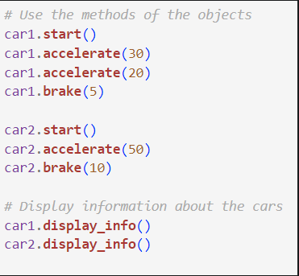
We have 2 classes of Car, then with the methods to perform actions like starting, accelerating, and braking the cars. The display info shows details of each car,

